# CS4112/CS54111 INTRODUCTION TO DATA SCIENCE

# Exercise.1: Read the provided CSV file of the AMAZON Stock Prices (AMZN.csv) and print the first six entries of this file.

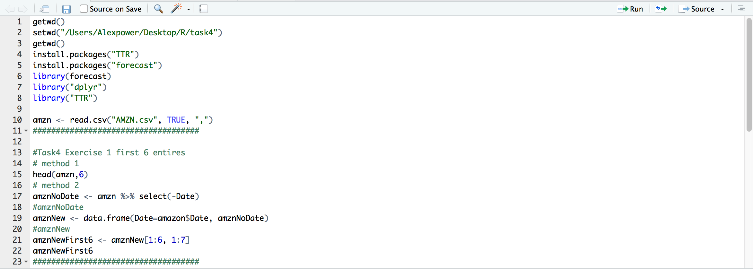

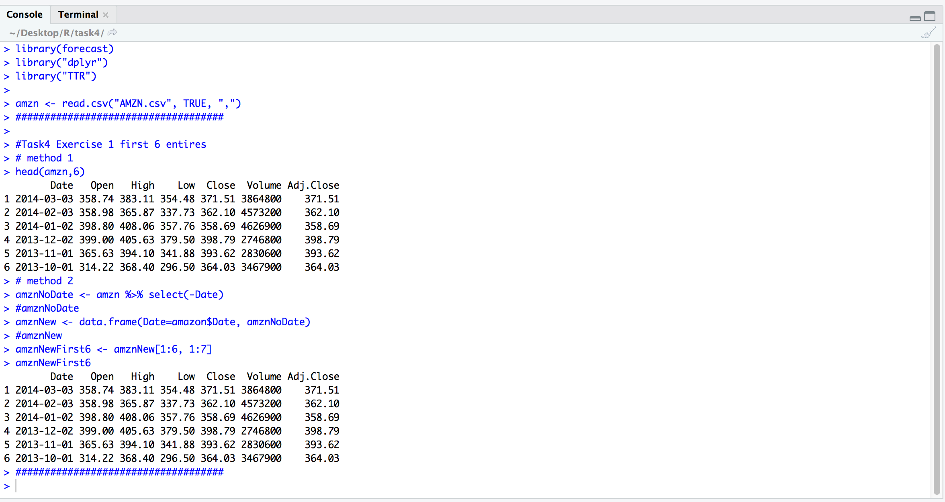

**Exercise.2: Convert the closing prices on the 5th column to a time series with the following changes: When creating the time series, you need to reverse the 5th column order (i.e. there are 12 monthly prices in a year). Plot the resulting time series(amzn_ts). The plot looks like this:**

I used rev() function to reverse the closing data here :

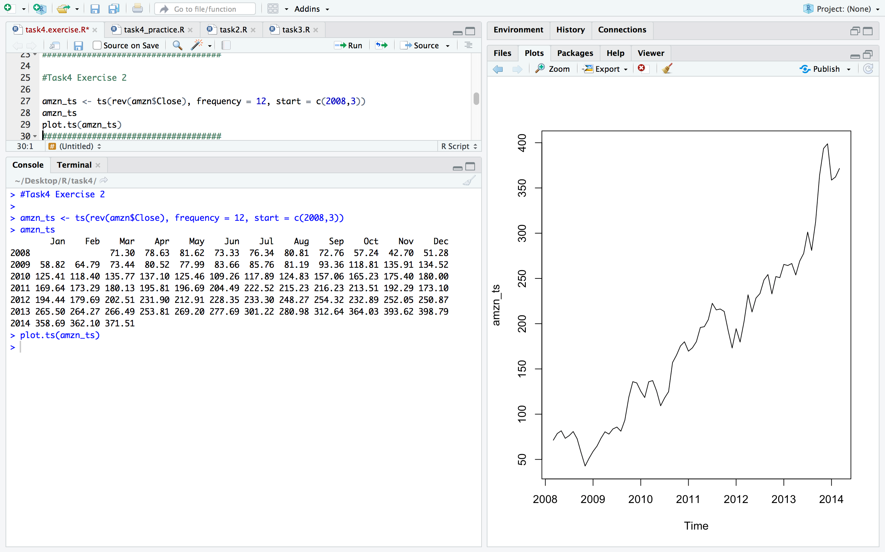

**Exercise.3: Apply one of the additive models on the amzn_ts (e.g. log) and plot the result. The output looks like this:**

I used log() function here :

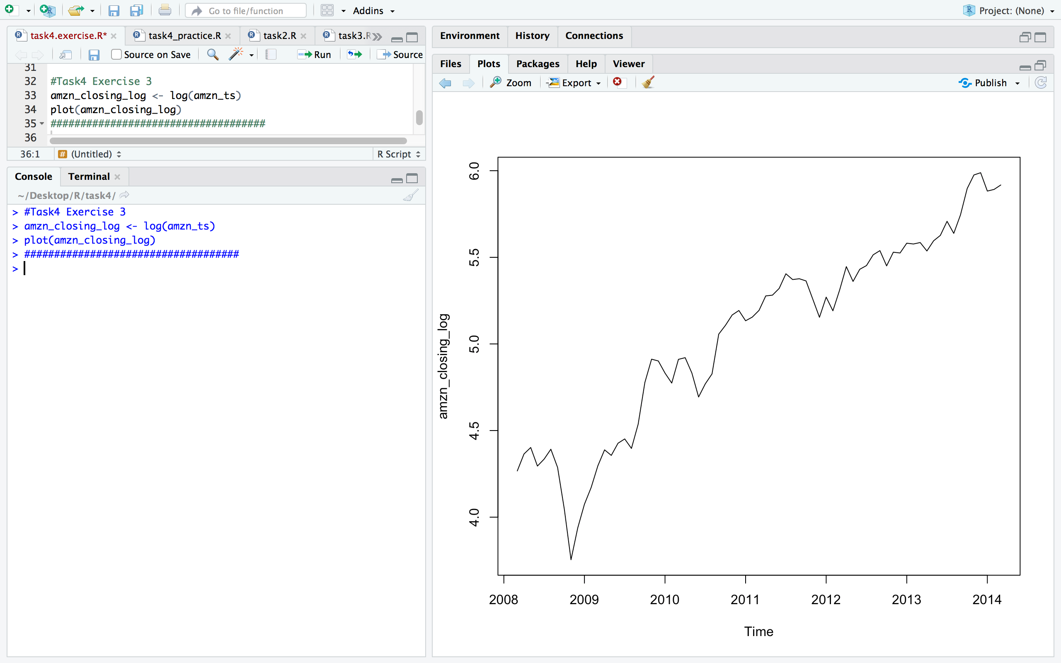

**Exercise.4: Now decompose the amzn_ts and *report on what you can notice on the stock prices trend*? Plot first the decomposed time series. The output of the plot looks like this:**

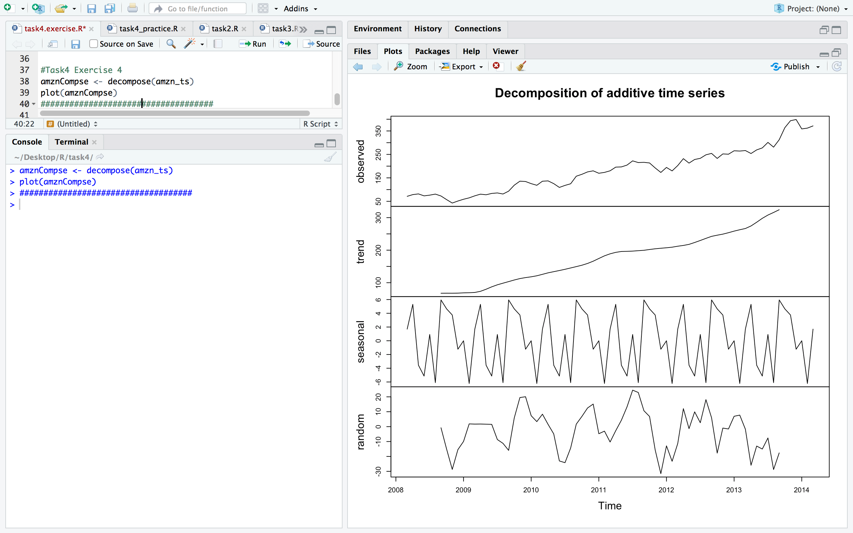

**Report on trend:**

According to the plots above, we noticed that the trend of Amazon stock prices is showing up with an ascending line, which means that the Amazon stock prices has been increasing in the last few years.

**Exercise.5: Smooth your amzn_ts using the Holtwinter() method and plot the smoothed time series. The smoothed time series looks like this:**

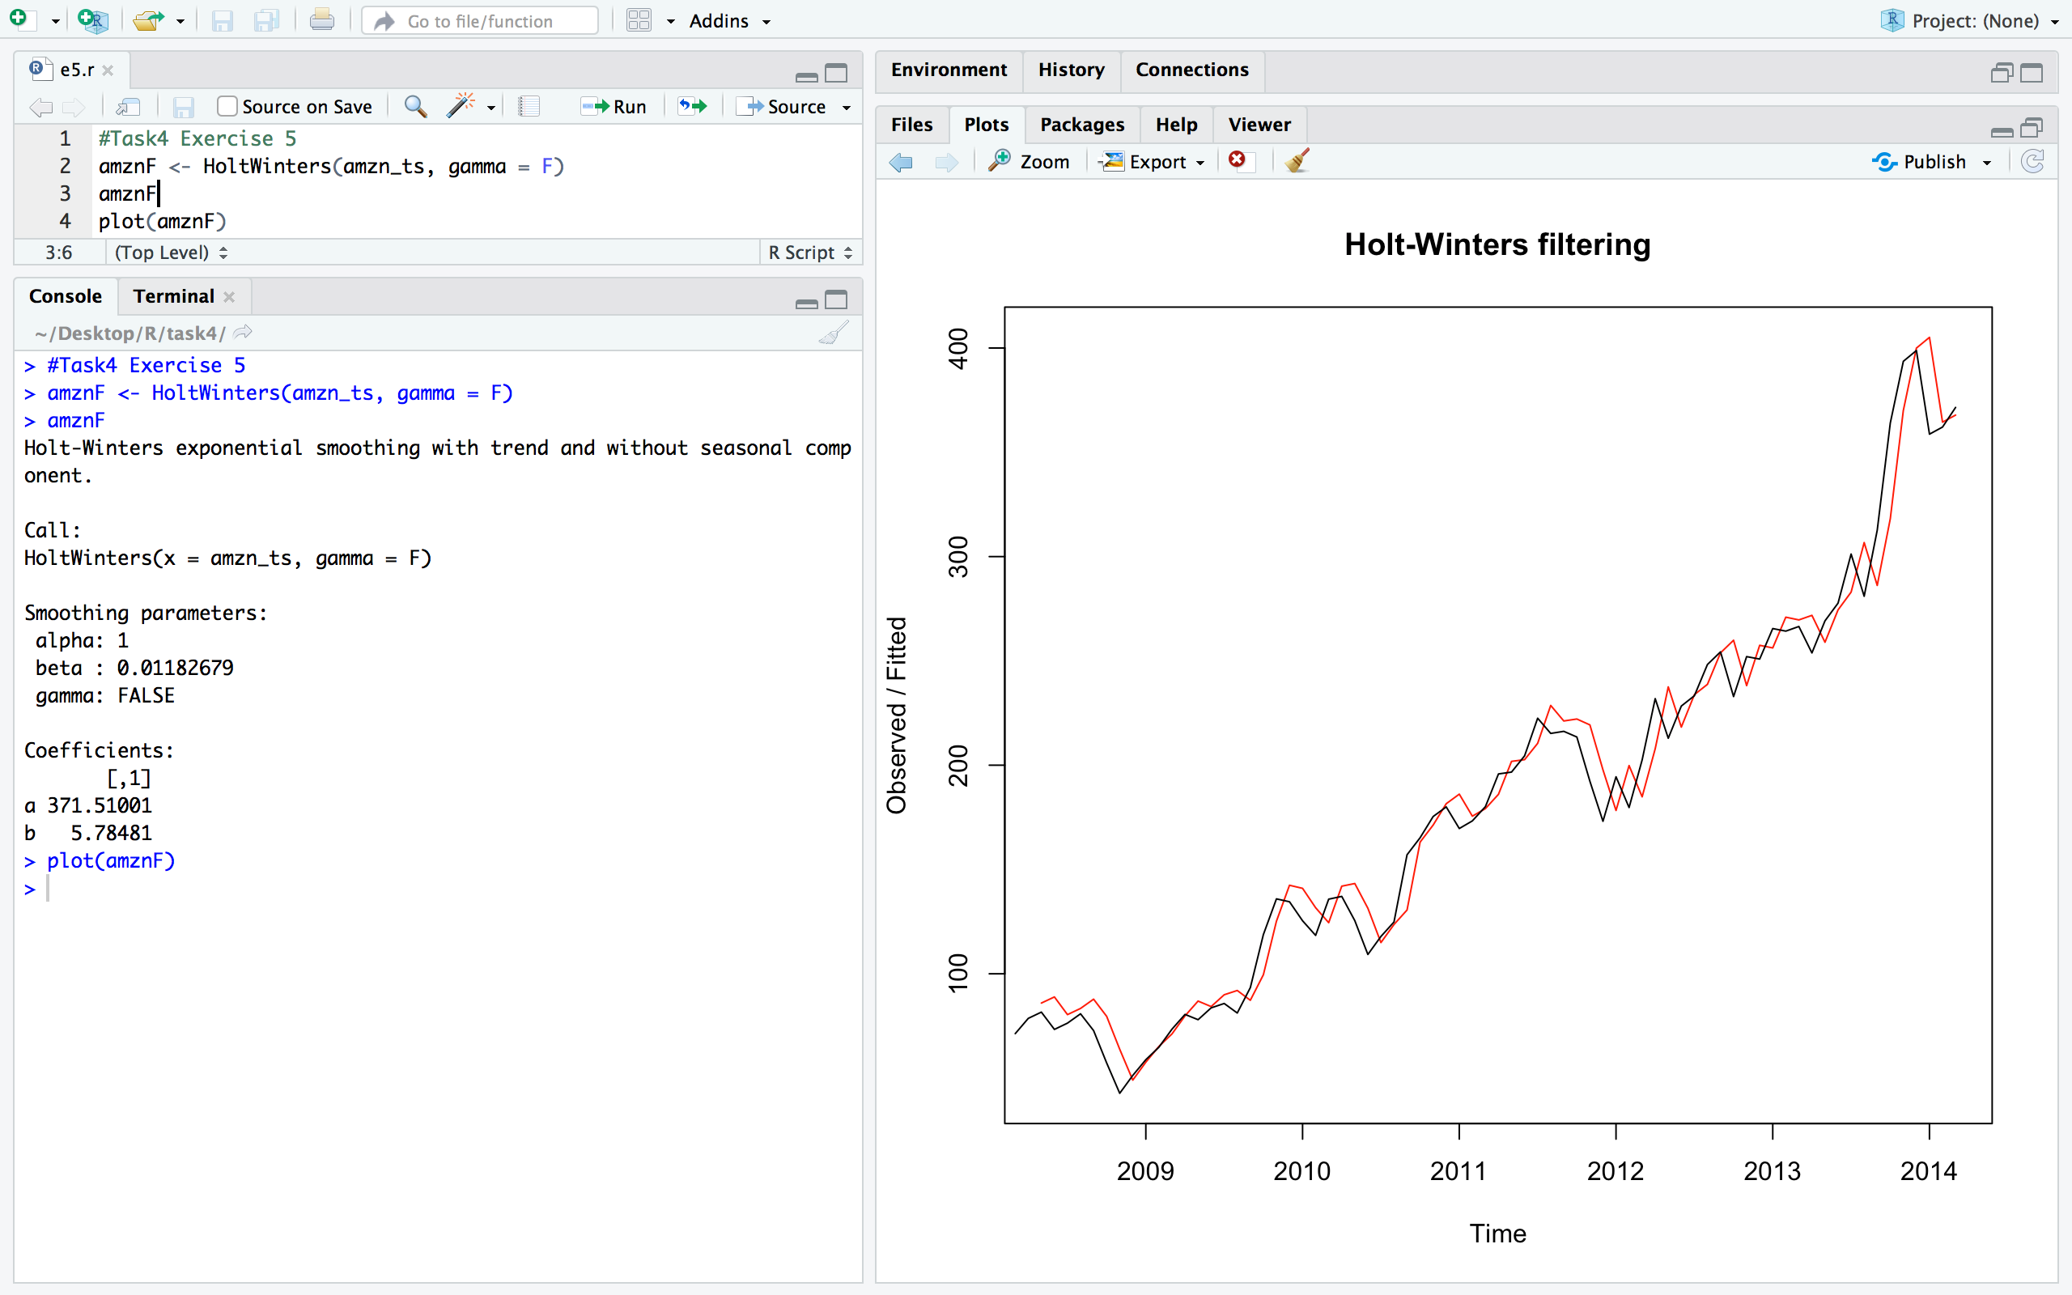

**Now use the forecast library and try to forecast future predictions of the closed stock prices of amazon. The future prediction plot looks like this:**

Method 1:

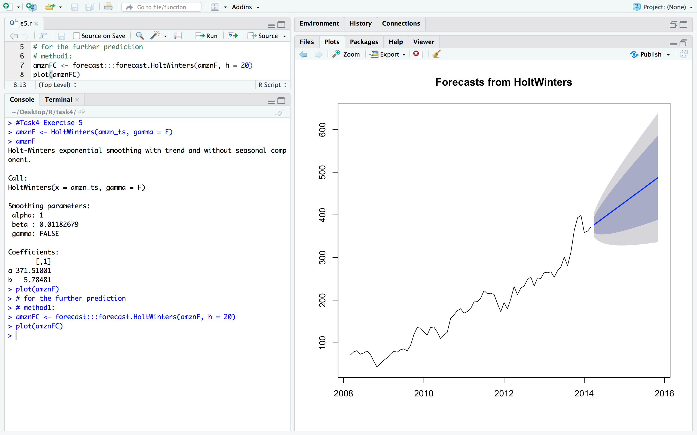

Method 2:

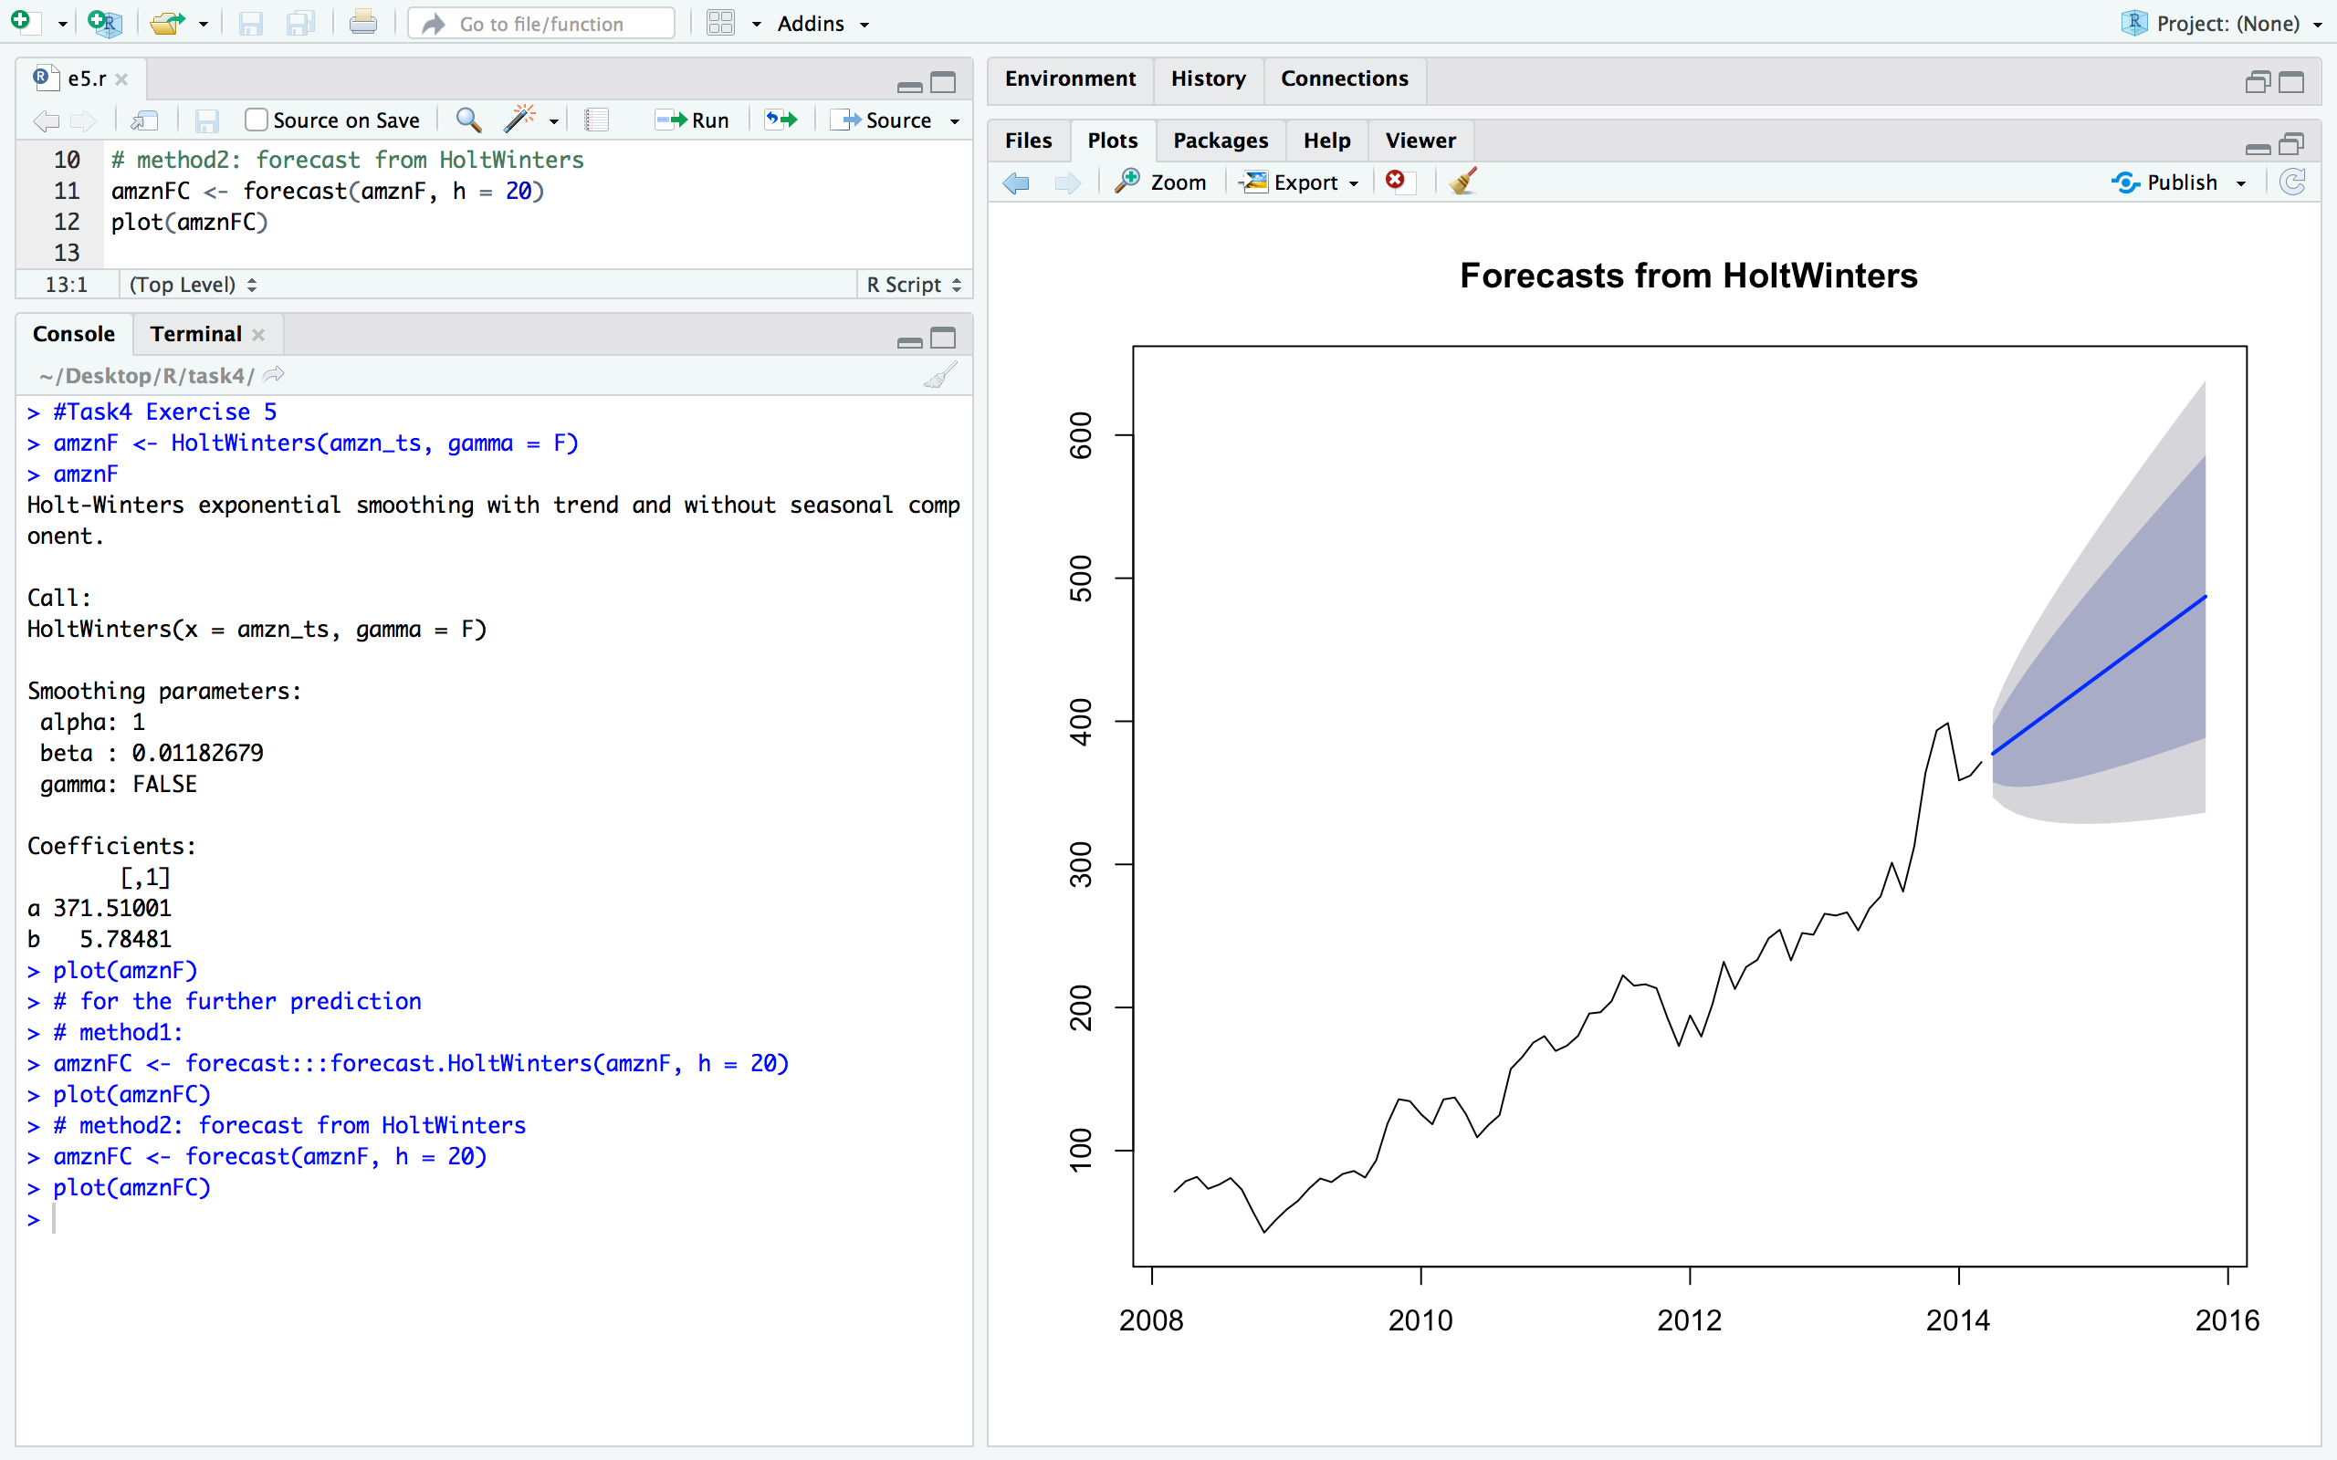

Method 3: Using ARIMA function ( auto.arima()), this method does work but did not smooth the trend.

